Kelompok : 11
Nama Anggota :
- Putri Nawwalin Nikmah (2304020019)
- Aulia Faiqoh (2304020032)
- Nashwa Aina Salsabila (2304020041)

Data: https://docs.google.com/spreadsheets/d/1qYTlcznTdG_MfaklBfiFKoZn1Pcj5MdH0JfxAjn0yF0/edit?gid=1549360938#gid=1549360938

Sintaks untuk menampilkan Data:
import pandas as pd
import matplotlib.pyplot as plt

Digital= pd.read_csv('Digital.csv')

from google.colab import drive
drive.mount('/content/drive')

Digital.head()
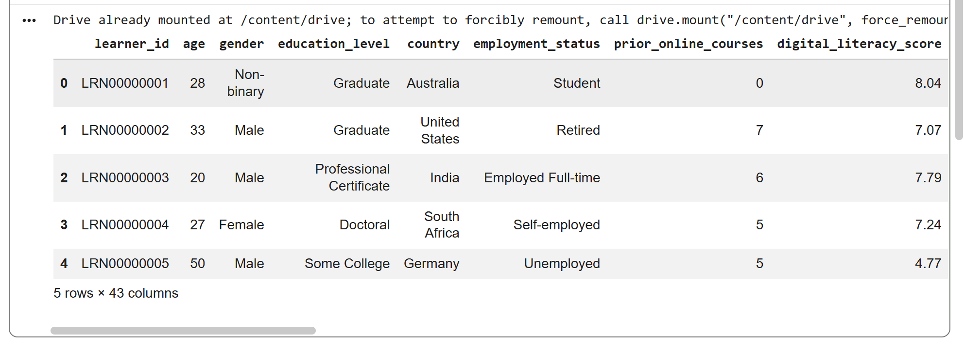

Sintaks untuk menampilkan diagram lingkaran “Country”
import pandas as pd
import matplotlib.pyplot as plt

Digital= pd.read_csv('Digital.csv')

from google.colab import drive
drive.mount('/content/drive')

Digital.head()

plt.figure()
plt.pie(data_pie, labels=data_pie.index, autopct='%1.1f%%')
plt.title('Diagram Lingkaran Country')
plt.show()

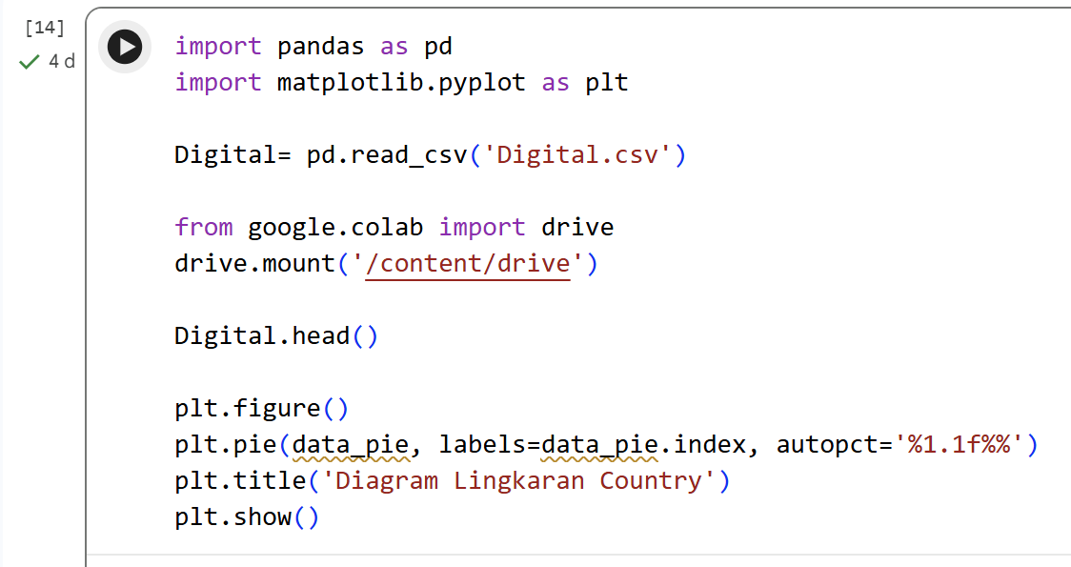
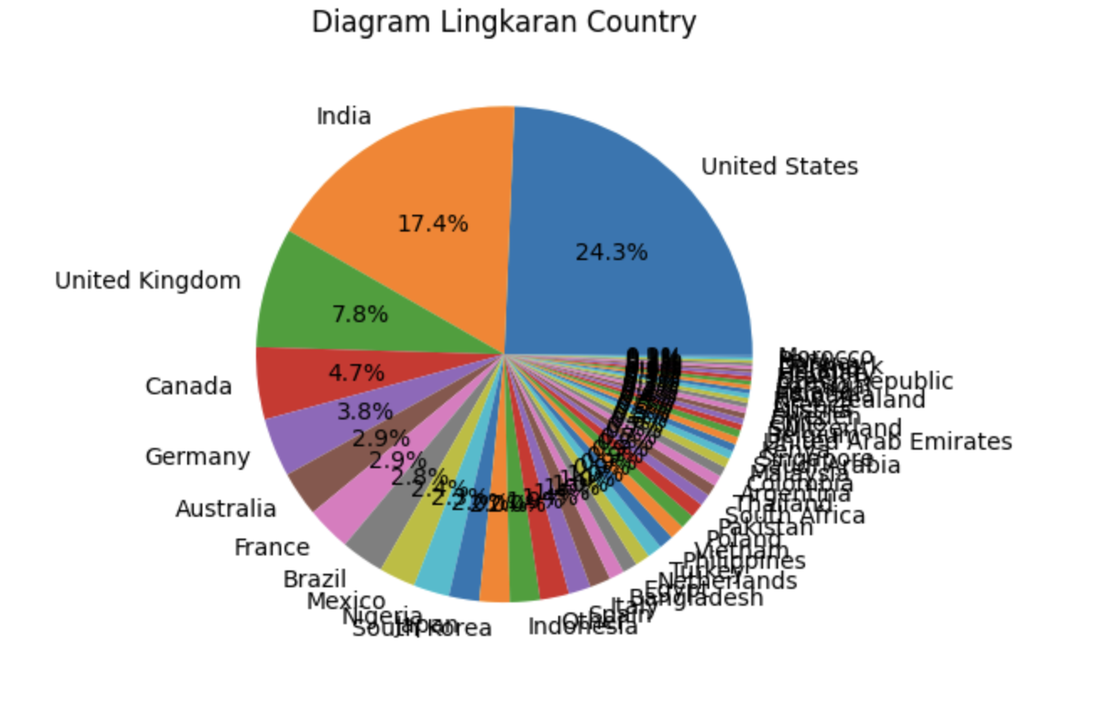

Sintaks untuk menampilkan diagram lingkaran “Gender”
import pandas as pd
import matplotlib.pyplot as plt
digital = pd.read_csv("digital.csv")
from google.colab import drive
drive.mount("/content/drive")

digital.head()

data_pie = digital['gender'].value_counts()

plt.figure()
plt.pie(data_pie, labels=data_pie.index, autopct='%1.1f%%')
plt.title('Diagram Lingkaran Gender')
plt.show()
